🧠 OPERATING SYSTEMS — LAST-MINUTE REVISION SHEET (MIDSEMS)

🔵 UNIT 1 — OS Basics, Structure, System Calls

🔹 Core Definitions (memorize verbatim)
- Operating System: Program that acts as an intermediary between user and hardware.
- OS as Resource Allocator: Manages CPU, memory, I/O, storage to ensure fairness & efficiency.

🔹 Dual-Mode Operation
- User mode → limited privileges
- Kernel mode → full privileges – complete access to hardware and system resources
- Mode bit protects OS from errant users
- System call → switches user → kernel and return call reverses to user

🔹 OS Services (list any 5)
- Program execution
- I/O operations
- File system manipulation
- Communication
- Error detection
- Resource allocation
- Protection & security

🔹 System Calls
- Process control (fork, exit, wait)
- File management
- Device management
- Information maintenance
- Communication
📌 Keywords examiners expect: trap, API, kernel

🔵 UNIT 2 — Process Management & IPC

🔹 Process States (DRAW THIS)
New → Ready → Running → Terminated
↑ ↓
Waiting ←───

🔹 PCB (Process Control Block)
Stores:
- Process state
- Program counter
- CPU registers
- CPU scheduling info
- Memory management info
- Accounting info
- I/O status info – devices allocated, files opened
❌ Not stored: partition info (MCQ favourite)

🔹 Schedulers
- Long-term → controls degree of multiprogramming
- Short-term → selects ready process for CPU
- Medium-term → swapping

🔹 IPC
- Shared memory → faster, needs synchronization by processes
- Message passing → safer, slower
- Direct (named) vs Indirect communication (mailboxes)

🔵 UNIT 3 — Threads

🔹 Thread Models (VERY IMPORTANT)
- Many-to-One
❌ No parallelism, blocking issue
- One-to-One
✅ True parallelism, higher overhead
- Many-to-Many
✅ Best balance (flexible)

🔹 Why Multithreading?
- Responsiveness
- Resource sharing
- Economy
- Scalability

🔵 UNIT 4 — CPU Scheduling ⭐⭐

🔹 Key Formulas
- Turnaround Time (TAT) = Completion − Arrival
- Waiting Time (WT) = TAT − Burst

🔹 Scheduling Algorithms (Know behaviour)
- FCFS → simple, convoy effect
- SJF → minimum average WT, starvation possible
- Priority → starvation, solved by aging
- Round Robin → depends on time quantum

🔹 Preemptive vs Non-Preemptive
- Preemptive → CPU can be taken away
- Non-preemptive → process keeps CPU till completion

🔹 Scheduling Criteria
- CPU utilization ↑
- Throughput ↑
- Waiting time ↓
- Turnaround time ↓
- Response time ↓
📌 Guaranteed question: Gantt chart + AWT + ATT

🔵 UNIT 5 — Process Synchronization ⭐⭐

🔹 Critical Section Requirements
- Mutual Exclusion
- Progress
- Bounded Waiting

🔹 Peterson’s Solution
- Uses:
  - turn
  - flag[i]
- Works for 2 processes only
- Satisfies all 3 CS conditions

🔹 Semaphores
- wait() / P() → decrement
- signal() / V() → increment
- Binary → mutex
- Counting → multiple instances

🔹 Problems with Semaphores
- Busy waiting
- Deadlock
- Starvation
- Programming errors

🔹 Classical Problems (name + idea)
- Producer–Consumer
- Readers–Writers
- Dining Philosophers

✅ FINAL MUST-PREPARE MIDSEM QUESTIONS (UNIT-WISE)

🔵 UNIT 1 – OS Basics, Structure, System Calls
- Explain Operating System as a resource allocator.
- Explain dual-mode operation with neat diagram and justify why it is required.
- List and explain Operating System services.
- Define system call and explain the types of system calls with examples.
- Differentiate between client–server and peer-to-peer systems.
- Explain virtual machine
- Multiprocessor systems with their types
- Responsibilities of OS – Process Management, Memory Management & Storage Management
- What are the advantages of using thread pools? Explain the scheduler activation scheme for communication between user thread library and kernel with neat diagram.

🔵 UNIT 2 – Process Management & IPC
- Explain process states with a neat state-transition diagram.
- Explain Process Control Block (PCB) and list all the information stored in it
- Differentiate between shared memory and message passing IPC models.
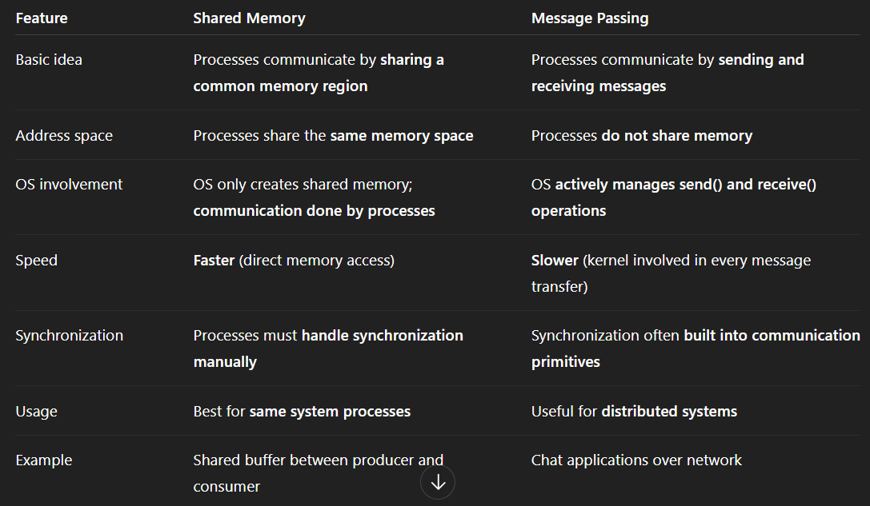

- Differentiate between direct and indirect communication and explain communication link properties.
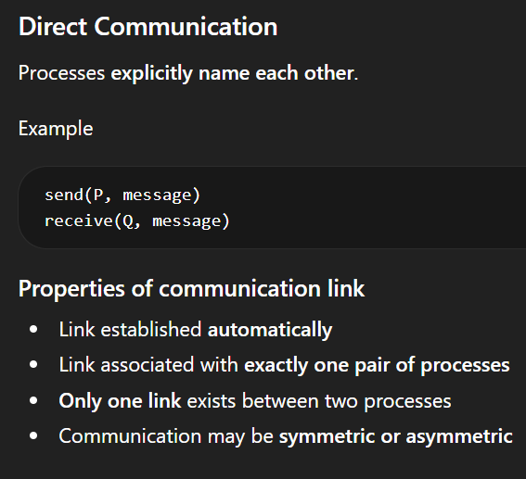
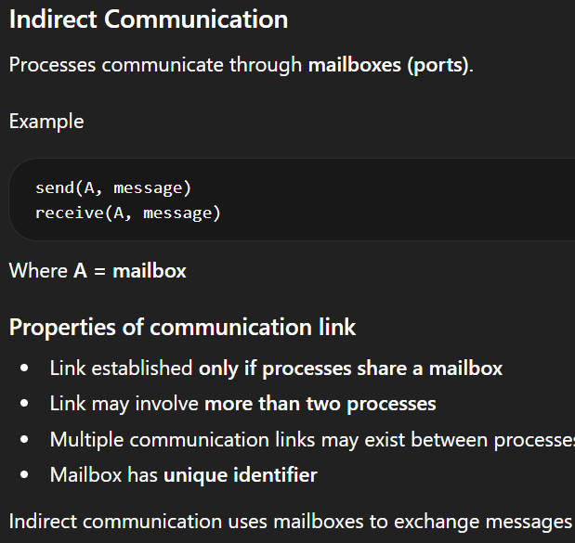
Explain the role of long-term, medium-term and short-term schedulers.
- Synchronous vs Asynchronous communication
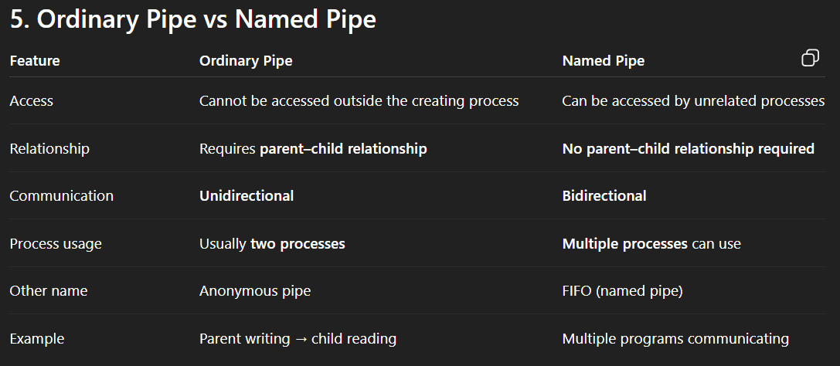
- Automatic and Explicit buffering
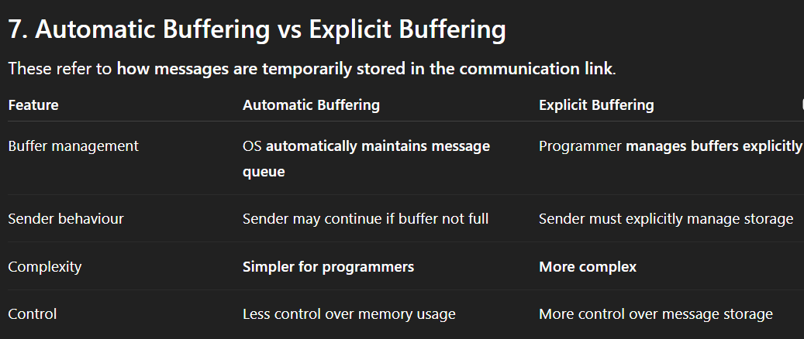

🔵 UNIT 3 – Threads
- Explain multithreading models (many-to-one, one-to-one, many-to-many) with diagrams.
- Why is multithreaded programming preferred over multiprogramming?
- Explain benefits of multithreaded programs
- Explain advantages and drawbacks of one-to-one and many-to-one threading models.
- Explain 5 threading issues encountered with multithreading
- What is fork? Explain the different ways in which a parent can terminate theexecution of one of the children for a variety of reasons.
- Any Four Differences Between Process and Thread
- Advantages of Thread Pool in Multithreading

🔵 UNIT 4 – CPU Scheduling ⭐ (HIGHEST WEIGHT)
- Solve CPU scheduling numericals using FCFS and SJF (Gantt chart)
- Solve Priority scheduling (preemptive) with Gantt chart and calculations.
- Solve Round Robin scheduling with given time quantum.
- Explain scheduling criteria and events where CPU scheduling decisions occur.
- Differentiate between preemptive and non-preemptive scheduling.
- Explain Dispatcher and dispatch latency
- Explain Soft, Hard and Firm Real time systems with 2 examples
- Explain context switching alongwith diagram

🔵 UNIT 5 – Process Synchronization ⭐ (VERY HIGH)
- Explain the Critical Section Problem and the three requirements of its solution.
- Explain Peterson’s Solution with pseudocode and prove correctness. (Memorize)
- Explain semaphores (binary & counting) with wait() and signal() (memorize function contents of wait and signal with whether greater lesser or equal 0).
- Explain problems associated with semaphores (busy waiting, deadlock, starvation, priority inversion).
- Producer–Consumer problem using semaphores (with pseudocode).
- Reader-Writer using semaphore
- Give the definition of the semaphore that eliminates busy waiting along with its wait and signal operations. Also explain how the busy waiting is eliminated.
- Define counting semaphore and binary semaphore
- How busy waiting is eliminated
- Applications of semaphores ( cases where used )

📘 UNIT–WISE COMPLETE QUESTION & CONCEPT INVENTORY
(From ALL main + extra + internal + MISAC + FISAC papers shared)

🔵 UNIT 1 — OS Basics, Structure, Services, System Calls
(L1, L2, T1, L3, L4, T2, L5)

🔹 Concepts Asked
- What is an Operating System – intermediary user & hardware
- Structure Of Computer – User, Application Prog., Hardware, OS
- OS as:
  - Resource allocator – manage + decide conflict for efficient resource utilisation
  - Control program – program execution, errors, prevent improper use
- Goals – execute user prog. for better problem solving, convenient comp use, hardware
- OS operations
- User mode vs Kernel mode
- Dual-mode operation
- OS services
- OS structure
  - Simple
  - Layered
  - Modular
- System boot (conceptual)
- API vs System call
- Client–Server model
- Peer-to-Peer model

🔹 Theory / Descriptive Questions
- Define Operating System
- Explain OS as a resource allocator
- Explain OS services with examples
- Explain dual-mode operation and why it is needed – to protect os from other system components
- Explain abstract view of computer system
- Explain OS structure with diagram
- Compare client–server and peer-to-peer systems
- Explain role of OS in memory management
- Explain role of OS in storage management

🔹 System Calls (VERY COMMON)
- Definition of system call
- Types of system calls:
  - Process control
  - File management
  - Device management
  - Information maintenance
  - Communication
- Difference between:
  - API and system call
  - Kernel and shell

🔹 Diagrams Asked
- Dual-mode operation diagram
- OS structure diagram
- Computer system components diagram
- User–kernel interface diagram

🔹 MCQ / Short Facts
- Gesture → GUI
- API definition
- Kernel vs shell
- Who controls degree of multiprogramming
- Which mode protects OS from errant users

🔵 UNIT 2 — Process Management & IPC
(T3, L6)

🔹 Concepts Asked
- Process
- Program vs Process
- Process states
- Process state transitions
- Process Control Block (PCB)
- Process identifiers (PID)
- Operations on processes
- Parent–child processes
- Swapping
- Interprocess Communication (IPC)
- Schedulers:
  - Long-term
  - Medium-term
  - Short-term
- Degree of multiprogramming
- Concurrency
- Parallelism

🔹 Theory / Descriptive Questions
- Explain process states with diagram
- Explain PCB and its fields
- What information is stored in PCB
- Explain operations on processes
- Explain parent–child relationship
- Explain swapping
- Explain IPC models
- Differentiate shared memory and message passing
- Differentiate direct and indirect communication
- Explain properties of communication link
- Explain schedulers and their roles

🔹 Numerical / Logical Questions
- Identify process state at given time instants
- Process state transition based on events
- fork() based execution tracing
- Number of processes created by fork()
- Output of fork() programs
- PID / PPID value tracing

🔹 Diagrams Asked
- Process state diagram
- Queueing diagram
- IPC communication model diagram

🔹 MCQ / Short Facts
- What is not stored in PCB
- PID definition
- Logical address space sharing
- Difference between concurrency and parallelism
- Swapping definition

🔵 UNIT 3 — Threads
(L7)

🔹 Concepts Asked
- Thread
- Process vs Thread
- User-level threads
- Kernel-level threads
- Multithreading
- Multicore programming challenges
- Thread pools

🔹 Multithreading Models (ALL asked)
- Many-to-One
- One-to-One
- Many-to-Many
- Two-level model

🔹 Theory / Descriptive Questions
- Explain multithreading models with diagram
- Advantages and disadvantages of each model
- Why multithreading is preferred over multiprogramming
- Explain challenges in multicore programming
- Benefits of multithreaded programming
- Explain thread pools

🔹 Diagrams Asked
- Multithreading model diagrams
- User vs kernel thread diagram

🔹 MCQ / Short Facts
- Heavy-weight vs light-weight process
- Thread scheduling basics

🔵 UNIT 4 — CPU Scheduling
(L8, T4, L9)

🔹 Concepts Asked
- CPU scheduling
- Scheduling criteria:
  - CPU utilization
  - Throughput
  - Turnaround time
  - Waiting time
  - Response time
- Preemptive vs Non-preemptive
- Dispatcher
- Dispatch latency
- Starvation
- Aging

🔹 Scheduling Algorithms (ALL ASKED)
- FCFS
- SJF (preemptive & non-preemptive)
- Priority scheduling (preemptive & non-preemptive)
- Round Robin
- Multilevel Queue
- Multilevel Feedback Queue
- Linux scheduling (conceptual)

🔹 Numerical Questions
- Gantt chart construction
- Average waiting time
- Average turnaround time
- Effect of time quantum
- Scheduling decision events
- Compare algorithms numerically

🔹 Diagrams Asked
- Gantt chart
- Queueing diagram
- Multilevel queue diagram

🔹 MCQ / Short Facts
- Turnaround time suitability
- Non-preemptive behavior
- Which algorithm causes starvation
- Scheduling decision triggers

🔵 UNIT 5 — Process Synchronization
(L10, T5, L11)

🔹 Concepts Asked
- Critical section problem
- Mutual exclusion
- Progress
- Bounded waiting
- Race condition
- Busy waiting
- Atomic operations

